# SHEET -8 – FILE COMPRESSION -I

## 1. Tar Archive

1. Create a tar archive file of your home directory – tar -cvf backup.tar .

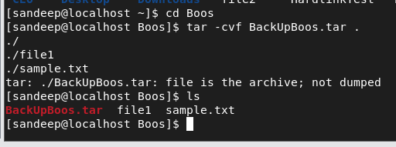

1. Create a tar archive file – tar -cvf etcbackup.tar /etc ( become root ) 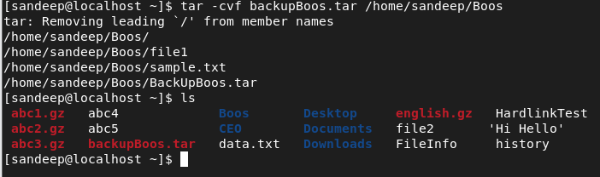
2. Move the etcbackup.tar to another directory root/Backups

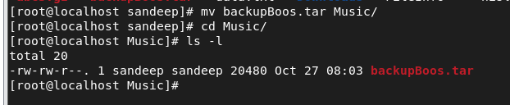

1. Create tar.gz file – tar -cvfz etcbackup.tar.gz .

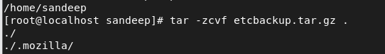



1. Move the gz file to root/Music

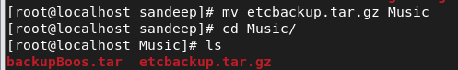

1. Create a tar.gz archive file of your home directory
2. Create tar.bz2 archive file – tar -cvfj etcbackup.tar.bz2 .

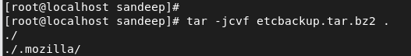

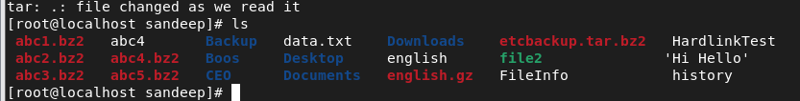

1. Move the bz file to root/Backups and compare the archive files using ls -lh

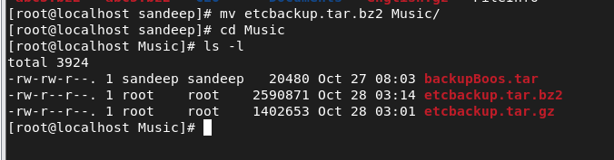

1. Create tar.bz2 file of your home directory
2. Untar files in the present directory
   1. tar -xvf backup.tar

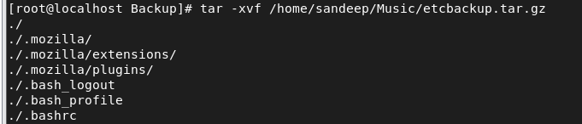

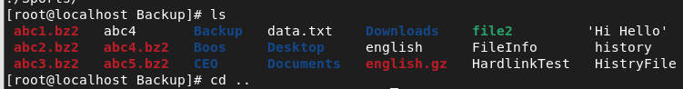

1. Untar files in specified directory
   1. Tar -xvf backup.tar -C /tmp/backup (create dir tmp/backup under your home directory)
2. Create tar archive file of a directory CEO under your home directory named CEOBackup.tar

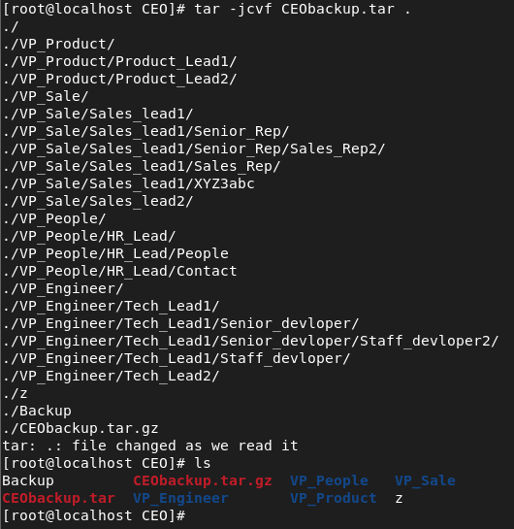

1. List all files under CEOBackup.tar using tar -tvf CEOBackup.tar

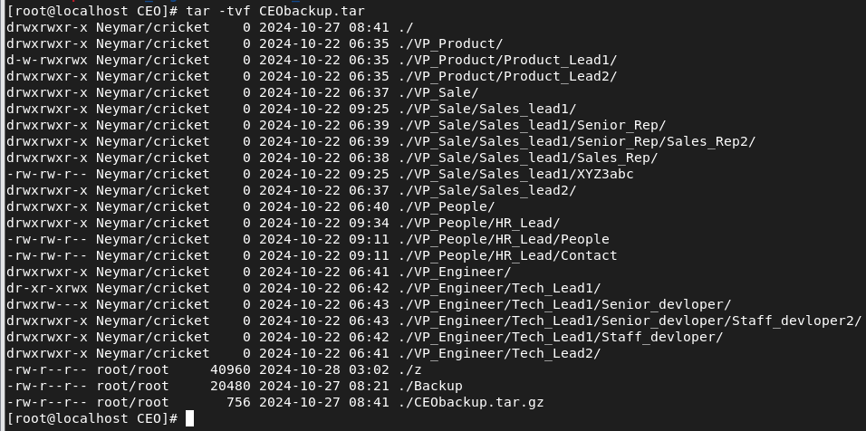

1. Add more files and directories to CEOBackup.tar using
   1. tar -rvf CEOBackup.tar fil1 file 2 file3 / dir1 dir2



1. Untar single files / multiple files and dirs using
   1. tar -xvf CEOBackup.tar file1 file2 file3 /dir1 dir2
2. Delete a file or directory from the tar acrchive using
   1. tar --delete -f CEOBackup.tar file1 /dir1

## 2. Gzip archive

1. Create a gzip archive of file(s)
   1. gzip filename



* 1. gzip filename1 filename2 filename3

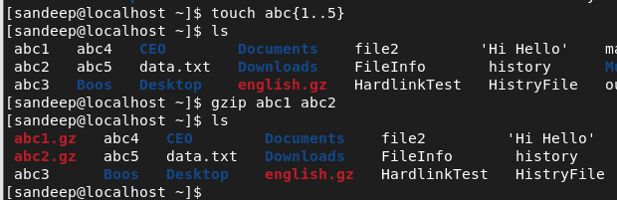

1. Create a gzip file keeping the original file
   1. gzip -k filename

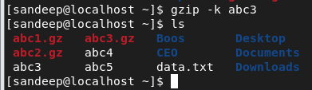

1. check out gzip -v filename cmd

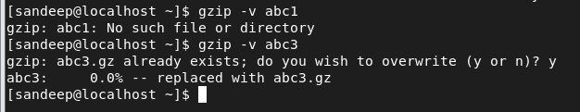

1. Create a gzip file for tar archive file CEOBackup.tar
   1. gzip CEObackup.tar (this way you can archive the directory and then apply gzip for compression)

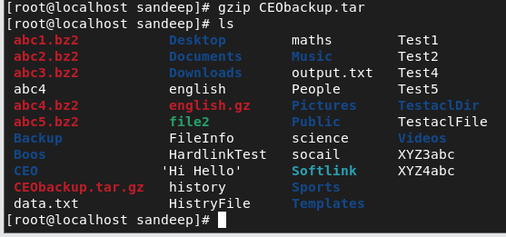

1. Create a gzip file for directory with subdirectories and files and observe i. gzip -r dirname

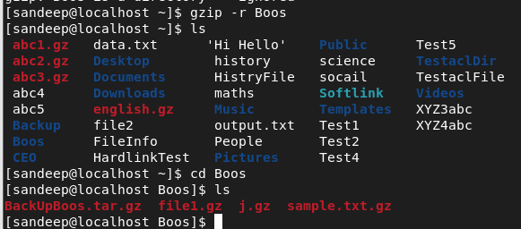

1. decompress gzip files
   1. gzip -d filename(s)

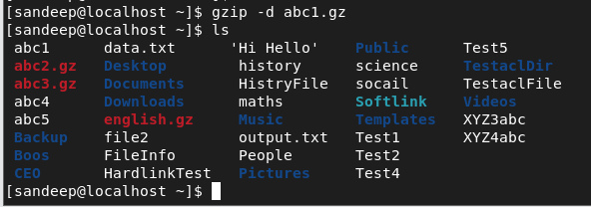

* 1. ii. gunzip filename(s)

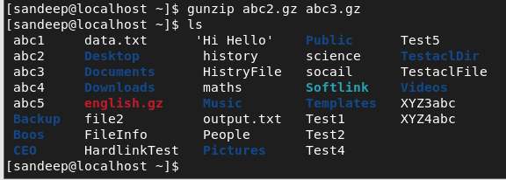

* 1. gzip -dr dirname

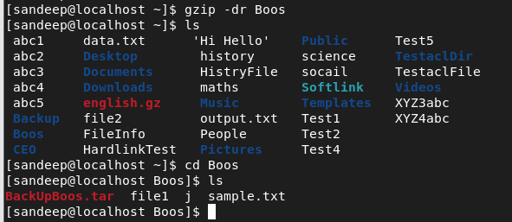

* 1. gunzip -r dirname

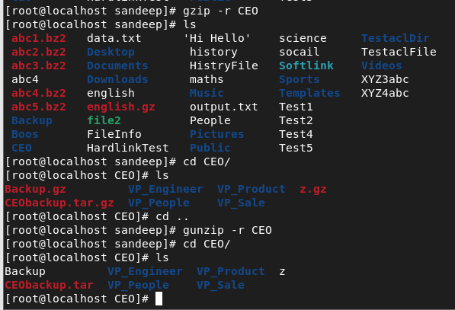

* 1. gzip -dk filename (keeping the compressed file)

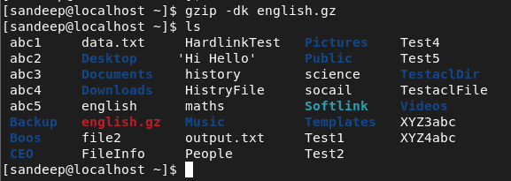

1. list the contents of gzip file/dir
   1. gzip -l filename.gz

ii. gzip -lr dirname

1

# SHEET -8 – FILE COMPRESSION -I

## 3. bzip2 archive

1. Create a bzip2 archive of file(s)
   1. bzip2 filename

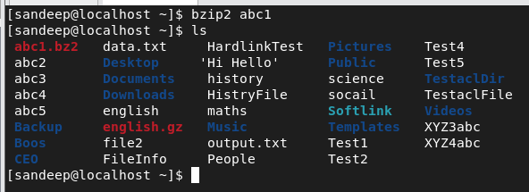

* 1. bzip2 filename1 filename2 filename3

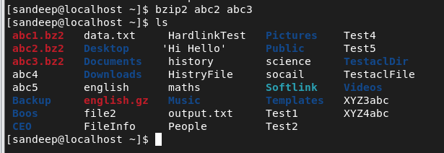

1. Create a bzip2 file keeping the original file
   1. bzip2 -k filename

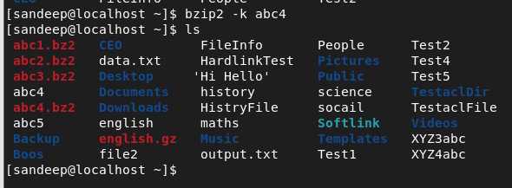

1. check out bzip2 -v filename cmd

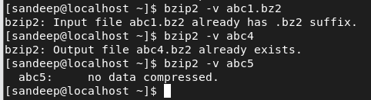

1. Create a bzip2 file for tar archive file CEOBackup.tar
   1. bzip2 CEObackup.tar (this way you can archive the directory and then apply gzip for compression)

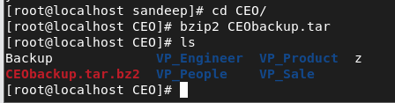

1. decompress bzip2 files
   1. bzip2 -d filename(s) ii. bunzip2 filename(s) iii. bzip2 -dk filename (keeping the compressed 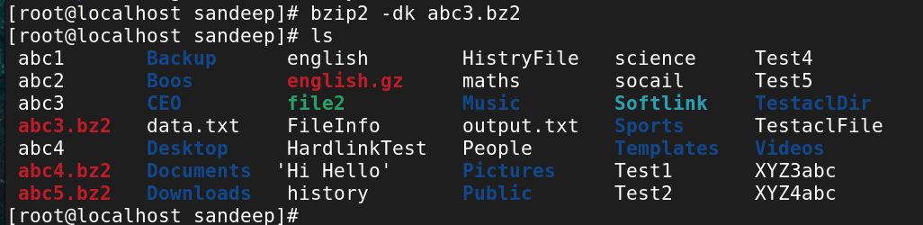file) 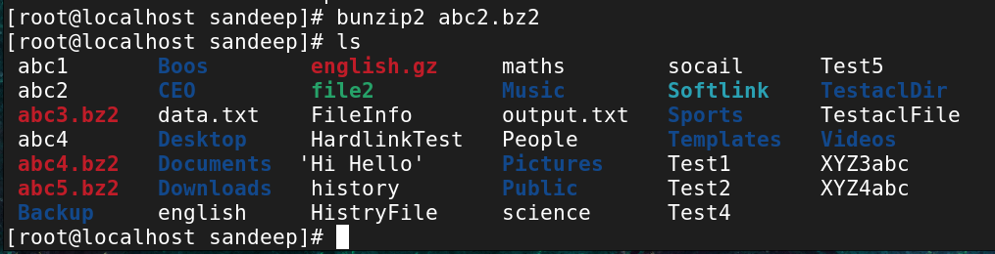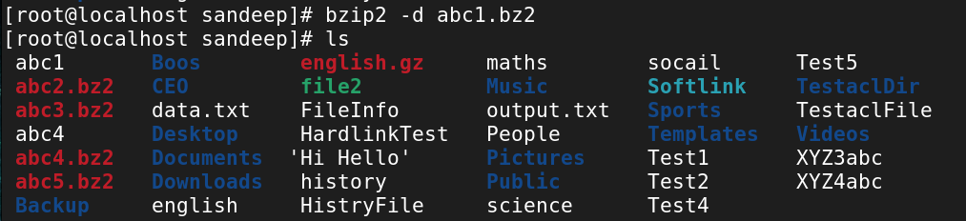

2